**Chapter 4**

**Applications of Derivatives**

**4.3 Maxima and Minima**

**Section Exercises**

91. If you are finding an absolute minimum over an interval  why do you need to check the endpoints? Draw a graph that supports your hypothesis.

Answer: Answers may vary

93. When you are checking for critical points, explain why you also need to determine points where is undefined. Draw a graph to support your explanation.

Answer: Answers will vary

95. Can you have a finite absolute maximum for  over  assuming *a* is non-zero? Explain why or why not using graphical arguments.

Answer: No; answers will vary

97. Is it possible to have more than one absolute maximum? Use a graphical argument to prove your hypothesis.

Answer: Since the absolute maximum is the function (output) value rather than the *x* value, the answer is no; answers will vary

99. **[T]** Graph the function For which values of , on any infinite domain, will you have an absolute minimum and absolute maximum?

Answer: When

**For the following exercises, determine where the local and absolute maxima and minima occur on the graph given. Assume domains are closed intervals unless otherwise specified.**

101.

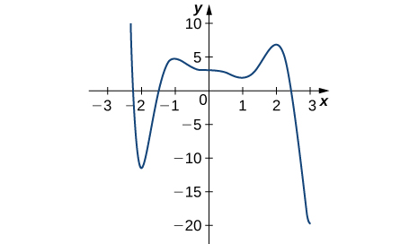

Answer: Absolute minimum at 3; Absolute maximum at –2.2; local minima at –2, 1; local maxima at –1, 2

103.

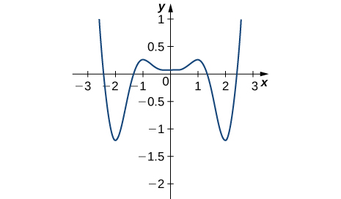

Answer: Absolute minima at –2, 2; absolute maxima at –2.5, 2.5; local minimum at 0; local maxima at –1, 1

**For the following problems, draw graphs of  which is continuous, over the intervalwith the following properties:**

105. Absolute minimum at  and absolute maximum at 

Answer: Answers may vary.

107. Absolute maxima at and  local minimum at  and absolute minimum at 

Answer: Answers may vary.

**For the following exercises, find the critical points in the domains of the following functions.**

109. 

Answer: 

111. 

Answer: None

113. 

Answer: 

115. 

Answer: None

117. 

Answer: 

**For the following exercises, find the local and/or absolute maxima for the functions over the specified domain.**

119. over 

Answer: Absolute maximum: , ; absolute minimum:,

121. over 

Answer: Absolute minimum:

123. over 

Answer: Absolute maximum:, ; absolute minimum: ,

125.  over 

Answer: Absolute maximum: absolute minimum:  

127.  over 

Answer: Absolute maximum:  absolute minimum:  

**For the following exercises, find the local and absolute minima and maxima for the functions over **

129. 

Answer: Absolute minimum: 

131. 

Answer: Absolute minimum:  local maximum:  local minimum:,

133. 

Answer: Local maximum:  local minimum: 

**For the following functions, use a calculator to graph the function and to estimate the absolute and local maxima and minima. Then, solve for them explicitly.**

135. [**T]**

Answer: Absolute maximum:  absolute minimum:

137. **[T]**

Answer: Local maximum:  local minimum:

139. **[T]**

Answer: Absolute maximum:, ; absolute minimum:

141. A ball is thrown into the air and its position is given by  Find the height at which the ball stops ascending. How long after it is thrown does this happen?

Answer: 

**For the following exercises, consider the production of gold during the California gold rush (1848–1888). The production of gold can be modeled by where is the number of years since the rush began () and is ounces of gold produced (in millions). A summary of the data is shown in the following figure.**

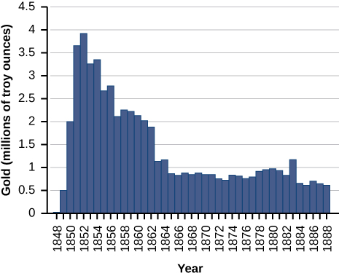

143. Find when the minimum (local and global) gold production occurred. What was the amount of gold produced during this minimum?

Answer: The global minimum was in 1848, when no gold was produced.

**Find the critical points, maxima, and minima for the following piecewise functions.**

145. 

Answer: Absolute minima:  local maximum at 

**For the following exercises, find the critical points of the following generic functions. Are they maxima, minima, or neither? State the necessary conditions.**

147.  given that 

Answer: No maxima/minima if is odd, minimum atif  is even

This file is copyright 2016, Rice University. All Rights Reserved.